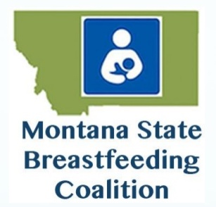
Deadline to submit application – August 1st, 2021
MONTANA BREASTFEEDS! 2021 World Breastfeeding Week Mini-Grant
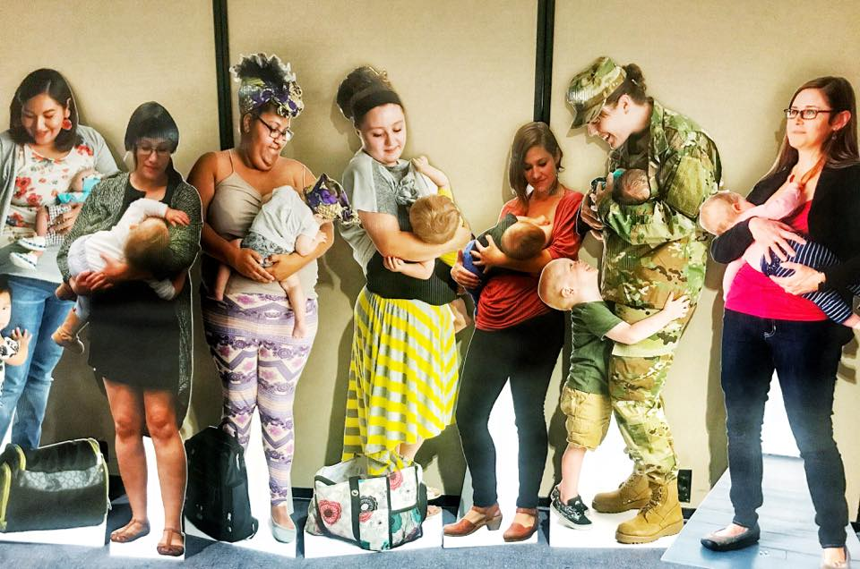
The Montana State Breastfeeding Coalition is offering a $200 award to a local MT breastfeeding coalition/ support groups to enhance breastfeeding programs/events in their community. Please return mini-grant application to TMiller6@mt.gov by August 1st, 2021.

Scholarships will be awarded based on these criteria:
- A Montana breastfeeding coalition/ breastfeeding support group/ hospital breastfeeding program;
- Financial need;
- Grant to be used to support coalition/support group work in their community.

Please fill out the following form in its entirety.
1. Applicant name: Click or tap here to enter text. 2. Date: Click or tap here.
3. Email: Click or tap here to enter text. 4. Phone number: Click or tap here.
5. Address: Click or tap here. City: Click or tap here. State/Zip: Click or tap.
6. Name of MT breastfeeding organization: Click or tap here to enter text.

Include in your narrative:

a. A brief description of your breastfeeding coalition/support group or service.
b. How the breastfeeding the mini-grant would be used to enhance your group’s breastfeeding work.

Click or tap here to enter text.

